We have reviewed the duplication results for the Agent ID duplicates and are now ready to process the merging of records. Below is the logic to be used for merging the records.

We have added two fields to the results in the table: Keep and Purge.

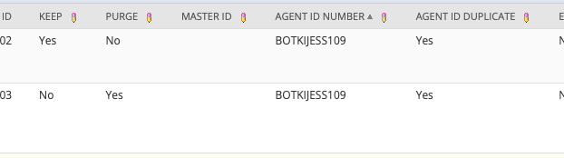

First part of the logic: We only want to focus on duplicates that have two records only and we only want to focus on records where Agent ID Duplicate is set to TRUE.

Example: The screenshot above has two duplicates. The screenshot below has three duplicates. We only want to focus on duplicate count for the same agent ID = 2, so we would ignore the one below.

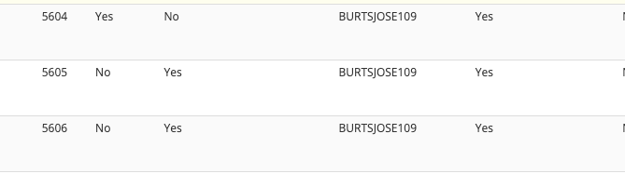

For the duplicate records, one has been marked as ‘keep’ and one has been marked as ‘purge’ in the custom table.

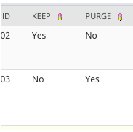

The logic of the script should be:

* Identify the internal ID of the agent record that is marked as ‘keep’ and the internal ID of the agent record that is marked as ‘purge’. This will be the internal ID of the actual Agent record and not the internal ID of the record in this custom table. In the example below you will see the two duplicates. The internal ID of the actual Agent record to ‘keep’ is 104821.

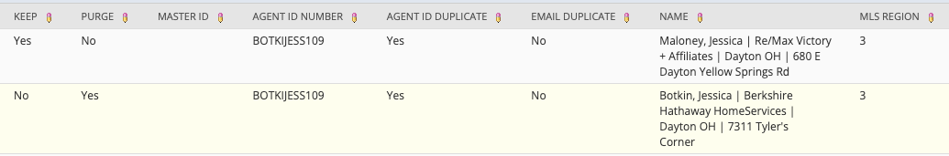

The first one has the ‘keep’ box checked. This will be the record we want to keep active. If I lookup that Agent ID I will see the internal id is 104821.

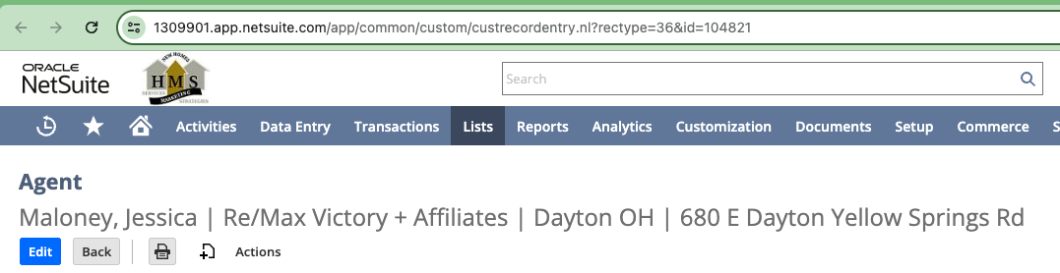

The second record has the Purge box checked. This is the Agent we will want to mark as Inactive. If I lookup the Agent ID I will see the internal ID is 8086.

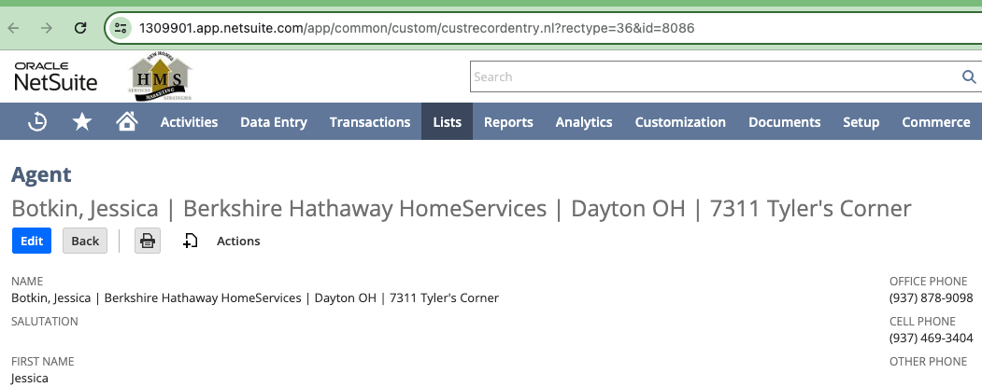

* There are three pieces that need to be moved/updated from the record marked Purge to the record marked Keep.
  + NRDS: There is a field on the Agent record titled NRDS ID (see below). If the value for this field on the Agent Record that was marked as Keep is empty (in the example above that is agent internal ID 104821), then we want to copy the value from that field from the Agent Record marked as Purge to the Agent Record marked as Keep.



For this example I can see the Agent ID that was marked to Keep has no value in the NRDS ID field.



But the Agent ID that was marked as Purge does have a value in the NRDS ID field



So we want to copy the value from the ‘Purge’ Agent ID to the ‘Keep’ Agent ID.

* CRM Count: If the Agent ID that was marked as Purge has CRM Records related to it (this can be identified by the CRM Record Count), then we want to update those CRM Records with the Agent ID that we want to keep.

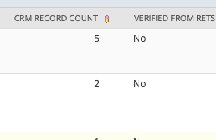

The CRM records can be found on the Agent record under Inquiries Made > CRM Records.

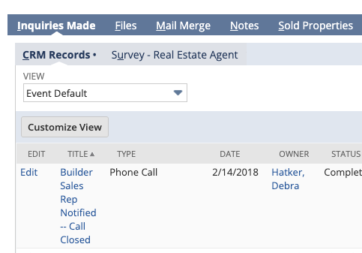

On these records is a field titled Agent Name. We need to update this field with the Agent that is marked as ‘keep’ (update the internal ID of the Agent Name on the CRM record).

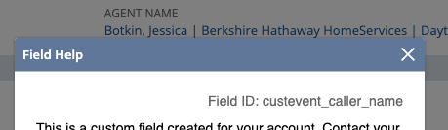

If I click Edit on the CRM Record I can change the name of the assigned agent. In the script for this example, you would update the custevent_caller_name value on the CRM record with ID 104821 (which is the Agent ID that we want to Keep).

Do this for all CRM records that are related to the Agent ID we want to Purge.

* Sold Properties: We want to take the same approach with the Sold Properties records that are related to the Agent ID that we want to Purge. If the Agent ID that was marked as Purge has Sold Property Records related to it (this can be identified by the Sold Properties Count), then we want to update those Sold Property Records with the Agent ID that we want to keep.

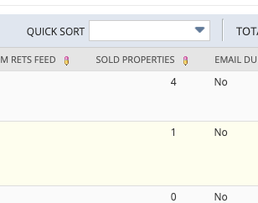

You can find the Sold Properties listed on the Agent Record under Sold Properties sub tab.

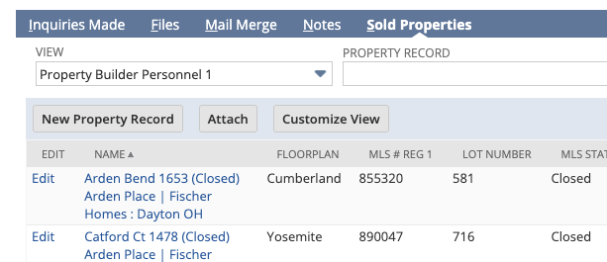

The agent name can be found on the Sold Property record under Sales Details in the Primary Real Estate Agent Name field.



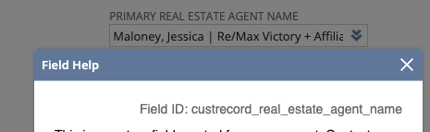

In the example above, we would want to update field ID custrecord_real_estate_agent_name with the ID value of 104821, which is the internal ID of the Agent Record we marked as Keep.

Finally, once all updates above have been done we want to mark the Agent Record that was marked as Purge inactive.

This can be done by setting field ID isinactive to TRUE.

